Michael Hironimus, CCIM
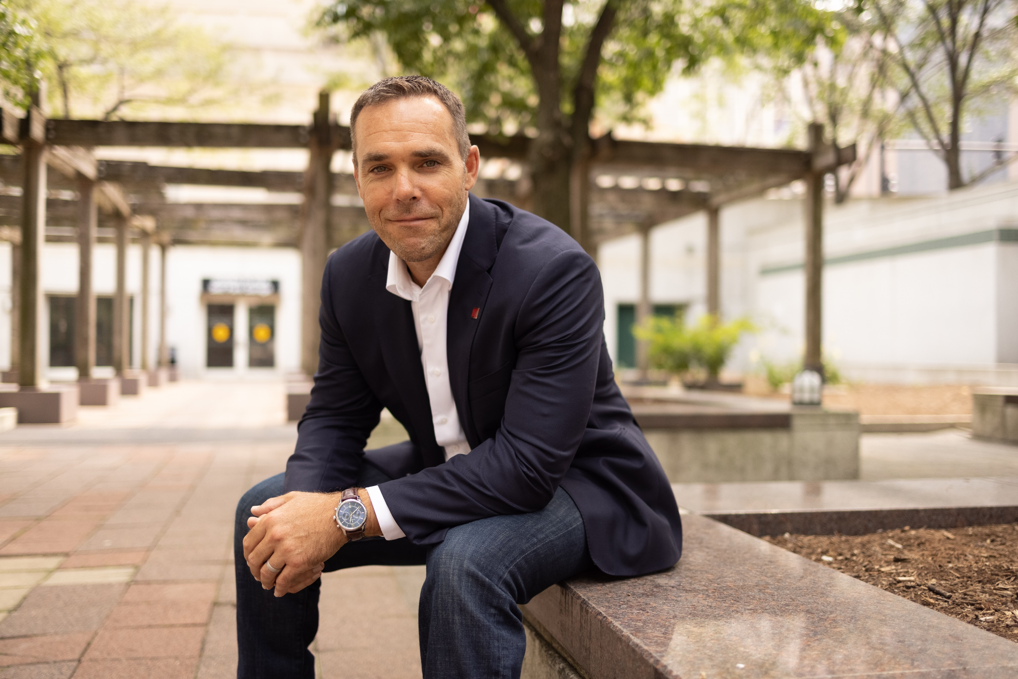

About

Michael Hironimus, CCIM, is a visionary in commercial real estate and AI-driven innovation, with over 20+ years of experience in investment analysis, portfolio management, and technology integration. As the founder of PropTech Integrations, he helps businesses harness AI-powered automation to enhance efficiency, optimize workflows, and drive smarter decision-making through customized solutions.
A recognized leader in bridging real estate and emerging technology, Michael is the creator of Implementing AI in CRE: A Practical Guide, a course designed to equip industry professionals with practical, real-world AI applications. His expertise has made him a sought-after educator and speaker, guiding the industry’s adoption of AI-driven strategies.
As a Senior Instructor for the CCIM Institute, Michael teaches Market Analysis (CI-102) and serves as Chairman of the CCIM Technology Advisory Committee and Curriculum Subcommittee, where he is at the forefront of integrating AI and advanced analytics into real estate education. His work in the President’s Advisory Group further shapes the Institute’s approach to technology adoption.
Beyond education, Michael is also the Principal of Duckridge Realty Advisors, specializing in private portfolio and asset management for high-net-worth investors. He applies a data-driven, forward-thinking approach to investment strategy, ensuring clients stay ahead of market trends.
With a passion for transforming commercial real estate through AI, automation, and predictive analytics, Michael is a driving force in modernizing the industry. His leadership and vision continue to redefine how real estate professionals adapt, innovate, and thrive in the digital age.

